**Task#1:**

1.Create a Function that Calculates the Factorial

* **Index.html**

|  |
| --- |
| <!DOCTYPE html>  <html lang="en">  <head>  <meta charset="UTF-8">  <meta name="viewport" content="width=device-width, initial-scale=1.0">  <title>Factorial Calculator</title>  </head>  <body>  <h1>Factorial Calculator</h1>  <script>  function fac() {  let num=prompt("ENTER A NUMBER:");  if (isNaN(num) || num < 0) {  return; }  let factorial = 1;  for (let i = 1; i <= num; i++) {  factorial *= i; }  document.write(factorial *= i); }  </script>  <button onclick="fac()">CALC</button>  </body>  </html> |

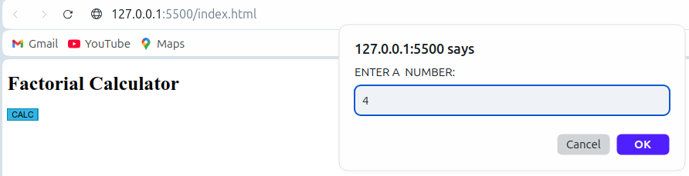**Output:**



2. Create a function changeBackgroundColor(color) that changes the background color of the page when a button is clicked. Use a color input or predefined color values.

TASK#2:

* **Index.html**

|  |
| --- |
| <!DOCTYPE html>  <html lang="en">  <head>  <meta charset="UTF-8">  <meta name="viewport" content="width=device-width, initial-scale=1.0">  <title>Change Background Color</title>  </head>  <body>  <h1>Change Background Color</h1>  <button onclick="changeBackgroundColor('red')">Red</button>  <button onclick="changeBackgroundColor('blue')">Blue</button>  <button onclick="changeBackgroundColor('green')">Green</button>  <button onclick="changeBackgroundColor('yellow')">Yellow</button>  <button onclick="changeBackgroundColor('white')">Reset</button>  <script>  function changeBackgroundColor(color) {  document.body.style.backgroundColor = color;  }  </script>  </body>  </html> |

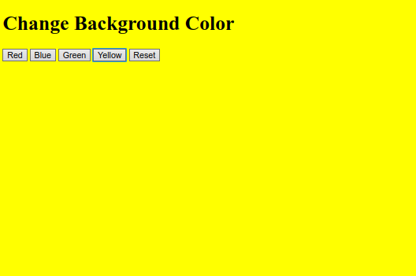**Output:**

3. . DOM Manipulation

• Create a button and a div element on the page.

• Add an event listener to the button that changes the text of the div when clicked.

• Initially, the div should contain "Click the button to change me."TASK#3:

* **Index.html**

|  |
| --- |
| <!DOCTYPE html>  <html lang="en">  <head>  <meta charset="UTF-8">  <meta name="viewport" content="width=device-width, initial-scale=1.0">  <title>DOM </title>  </head>  <body>  <button id="changeTextButton">Click Me</button>  <div id="message">Click the button to change me.</div>  <script>  const button = document.getElementById('changeTextButton');  const messageDiv = document.getElementById('message');    button.addEventListener('click', () => {  messageDiv.textContent = 'The text has been changed!';  });  </script>  </body>  </html> |

**OUTPUT:**

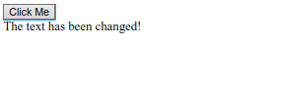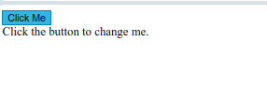

4.Create a toggle button from html,css,js.

* **Index.html:**

|  |
| --- |
| <!DOCTYPE html>  <html lang="en">  <head>      <meta charset="UTF-8">      <meta name="viewport" content="width=device-width, initial-scale=1.0">      <title>WEB</title>      <style>      .toggle-switch {          position: relative;          display: inline-block;          width: 60px;          height: 34px;    }      .toggle-switch input {          opacity: 0;          width: 0;          height: 0;    }      .slider {          position: absolute;          cursor: pointer;          top: 0;          left: 0;          right: 0;          bottom: 0;          background-color: #ccc;          transition: 0.4s;          border-radius: 34px;  }      .slider:before {          position: absolute;          content: "";          height: 26px;          width: 26px;          left: 4px;          bottom: 4px;          background-color: white;          transition: 0.4s;          border-radius: 50%;  }      input:checked + .slider {          background-color: #2196F3;  }      input:checked + .slider:before {          transform: translateX(26px);   }      </style>  </head>  <body>      <h2>Toggle Switch with Text</h2>      <label class="toggle-switch">          <input type="checkbox" id="toggle">          <span class="slider"></span>      </label>      <p id="status">Switch is OFF</p>      <div id="text-container">          <p id="text_1"></p>          <p id="text_2"></p>          <p id="text_3"></p>      </div>      <script>      const toggle = document.getElementById('toggle');      const status = document.getElementById('status');      const text1 = "MY WORLD";      const text2 = "MY BEAUTIFUL GREEN HOUSE IS LOVELY";      const text3 = "I SKIP THIS TERM!!!";      toggle.addEventListener('change', () => {          if (toggle.checked) {              status.textContent = 'Switch is ON';              document.getElementById("text_1").innerHTML = text1;              document.getElementById("text_2").innerHTML = text2;              document.getElementById("text_3").innerHTML = text3; }  else { status.textContent = 'Switch is OFF';              document.getElementById("text_1").innerHTML = '';              document.getElementById("text_2").innerHTML = '';              document.getElementById("text_3").innerHTML = '';  }  });      const mergedText = `${text1} ${text2} ${text3}`;      </script>  </body>  </html> |

**OUTPUT:**

